SIT215 Computational Intelligence
Assignment 3: Integrated Intelligent System Project
Student Name: Jin Kim
Student ID: 223715707

Cover Page Checklist
Task | Completed
Task 1: Baseline A* planner with constant speed | ✔
Task 2: Fuzzy inference system design | ✔
Task 3: Integrated intelligent system, replanning, and responsible evaluation | ✔
Task 4: Recorded video presentation submitted | ✔

1. Baseline A* Planner with Constant Speed
1.1 Problem and Environment Model
The problem I chose for this assignment is a goods delivery routing problem in the Melbourne CBD. The delivery agent starts at Flinders Street Station (N1) and needs to reach State Library Victoria (N9). I reused the same general delivery environment from Assignment 1, but I refined it in this assignment so that it can support distance-based travel time, fuzzy safe speed calculation, and replanning.
The environment is represented as a state-space graph. Each node represents a Melbourne CBD landmark, and each edge represents a possible road segment that the delivery truck can travel through. I kept the 20-node graph from Assignment 1 because it already includes a mix of transport hubs, shopping areas, intersections, and constrained laneways. The graph also contains 37 path segments, which matches the required graph size for this assignment.
In this graph, a state is the current landmark occupied by the delivery agent. An action is moving from one connected node to another. A movement is only allowed if an edge exists between the two nodes. This makes the environment suitable for A* search because every possible movement has a defined cost and the goal node is known.
In Assignment 1, the edge values were abstract path costs. For Assignment 3, I reused those values as a way to describe road condition and bumpiness:
Original Cost | Meaning in Assignment 1 | Use in Assignment 3
1 | Standard road segment | Smooth bumpiness
2 | Busy inner-city road or intersection | Moderate bumpiness
3 | Constrained laneway or difficult segment | Rough bumpiness
I reused this structure because it connects the new fuzzy system to the earlier search model. Instead of treating the original values only as abstract path costs, I use them to describe the bumpiness or movement difficulty of each road segment. This keeps the search component and the fuzzy component based on the same delivery environment.
Although the graph structure is reused from Assignment 1, the cost model is different in this assignment. Assignment 1 used abstract edge costs to compare road suitability, while Assignment 3 uses distance-based travel time under a constant speed of 100 km/h for the baseline planner. Because of this change, the baseline A* route in Assignment 3 can differ from the earlier Assignment 1 weighted-cost route.

Figure 1. State-Space Graph of the Melbourne CBD Delivery Environment
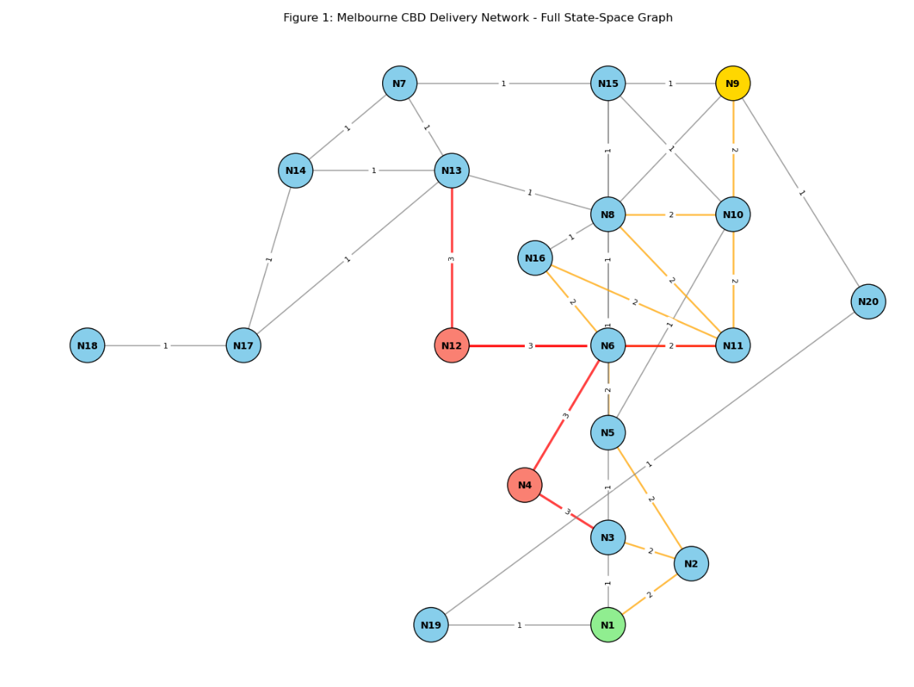Figure 1 shows the reused Melbourne CBD state-space graph from Assignment 1. The graph contains 20 landmark nodes and 37 path segments. N1 is the start node, N9 is the goal node, and constrained nodes such as N4 and N12 are highlighted because they represent narrow or less suitable truck routes. In Assignment 3, this same graph structure is extended with distance, bumpiness, and travel-time values so that fuzzy safe speed and replanning can be integrated.
Table 1. Edge Attribute Examples
Edge | Distance km | Original Cost | Bumpiness Label | Bumpiness Value
N1–N3 | 0.154 | 1 | Smooth | 2.0
N2–N5 | 0.309 | 2 | Moderate | 5.0
N3–N4 | 0.230 | 3 | Rough | 8.0
N6–N12 | 0.478 | 3 | Rough | 8.0
N8–N9 | 0.221 | 1 | Smooth | 2.0
Table 1 shows examples of how the original Assignment 1 road costs were translated into bumpiness values. I included representative smooth, moderate, and rough segments so that the connection between the graph model and the fuzzy model is clear. The full graph contains 37 path segments, but these examples show the modelling pattern used in the implementation.

1.2 Baseline Cost Function
For the baseline case, I assumed that the delivery truck can travel along every path segment at a constant speed of 100 km/h. This is not meant to be a realistic city driving speed. It is used as a controlled baseline so that the later fuzzy-informed planner can be compared against a simpler version of the same problem.
The edge cost in the baseline model is travel time:
travel time = distance / speed
Since distance is measured in kilometres and speed is measured in kilometres per hour, the travel time is converted into minutes:
travel time in minutes = (distance_km / 100) × 60
This gives every road segment a time-based cost. It also matches the goal of the assignment, which is to find the fastest route rather than only the shortest route by number of nodes.

1.3 Baseline Heuristic and Admissibility
For the baseline A* search, I used a straight-line distance heuristic. The heuristic estimates the remaining travel time from the current node to the goal node by using the straight-line distance to N9 and dividing it by the maximum baseline speed of 100 km/h.
h(n) = straight-line distance from n to goal / 100 km/h
This heuristic is admissible because the straight-line distance between two locations is never longer than the actual road path through the graph. Also, the heuristic uses the fastest possible speed in the baseline model. Because of this, it gives an optimistic estimate of the remaining travel time and does not overestimate the actual cost to the goal.
The A* evaluation function is:
f(n) = g(n) + h(n)
Here, g(n) is the actual travel time from the start node to the current node, h(n) is the estimated remaining travel time, and f(n) is the total estimated cost. This allows the planner to balance the cost already travelled with the estimated cost still remaining.
Figure 4. Baseline A* Route with Constant Speed

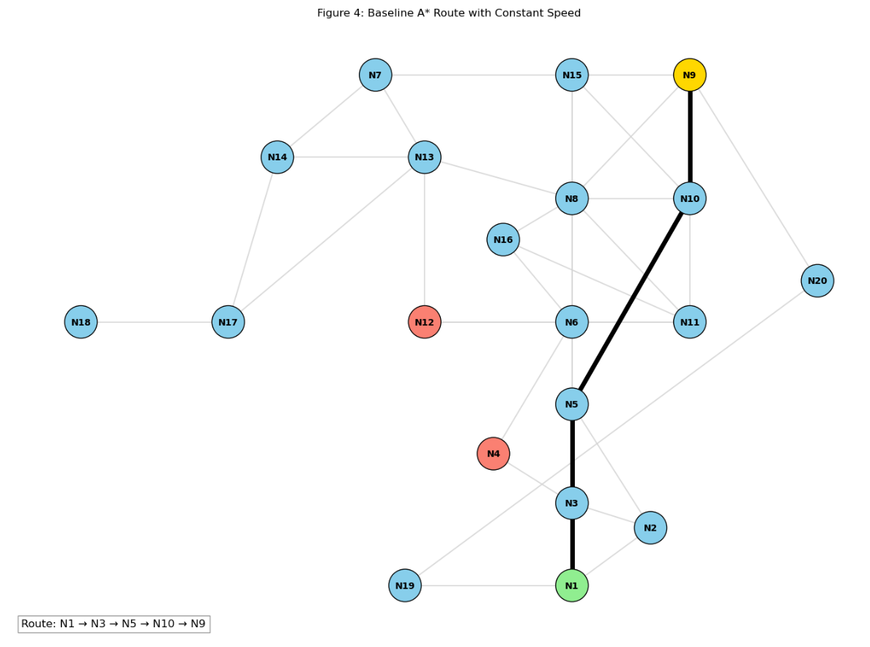 Figure 4 shows the baseline A* route from N1 to N9 under the constant-speed assumption. The highlighted path follows N1 → N3 → N5 → N10 → N9. This figure provides a visual reference point before fuzzy safe speeds and school-zone replanning are introduced.
The baseline result is useful, but it is also limited. It assumes that every road segment can be travelled at 100 km/h, even if the road is rough or the cargo is fragile. This is why fuzzy logic is added in the next part of the system.

1.4 Baseline A* Result
Using the constant-speed baseline, the A* planner found the following route:
N1 → N3 → N5 → N10 → N9
The total distance for this route was approximately:
0.990 km
The total travel time under the constant 100 km/h speed assumption was approximately:
0.594 minutes
This route provides the baseline result before fuzzy safe speeds and school-zone replanning are introduced.
Table 2. Baseline A* Search Trace
Expanded Node | g(n) minutes | h(n) minutes | f(n) minutes
N1 | 0.0000 | 0.5684 | 0.5684
N3 | 0.0923 | 0.4903 | 0.5826
N5 | 0.1854 | 0.4015 | 0.5869
N10 | 0.5386 | 0.0557 | 0.5943
N9 | 0.5943 | 0.0000 | 0.5943
Table 2 shows how A* selected nodes during the baseline search. The values of g(n), h(n), and f(n) make the decision process easier to follow. Instead of only showing the final route, this trace shows how the planner gradually moved toward the goal by considering both travelled cost and estimated remaining cost.
Table 3. Baseline Route Summary
Start | Goal | Path | Total Distance km | Total Time minutes
N1 | N9 | N1 → N3 → N5 → N10 → N9 | 0.990 | 0.594

2. Fuzzy Inference System Design
2.1 Purpose of the Fuzzy System
The fuzzy inference system calculates the maximum safe speed for each road segment. This is the main reasoning component of the integrated system. Instead of assuming that all roads have the same speed, the fuzzy system adjusts the safe speed based on two inputs:
Cargo Fragility
Road Bumpiness
This builds from my Assignment 2 fuzzy system, where I used cargo fragility and traffic conditions to reason about delivery handling priority. For this assignment, I changed the output from handling priority to maximum safe speed, because the A* planner needs a speed value to calculate travel time.
The basic reasoning is that fragile goods and rough roads should reduce the safe speed. For example, if the cargo is very fragile and the road segment is rough, the truck should not treat that segment the same as a smooth road with durable cargo.

2.2 Fuzzy Variables and Membership Functions
The first input variable is Cargo Fragility. It uses a 0 to 10 scale.
Linguistic Label | Meaning
Low | Durable cargo with low damage risk
Medium | Somewhat delicate cargo
High | Fragile cargo that needs careful movement
The second input variable is Road Bumpiness. It also uses a 0 to 10 scale.
Linguistic Label | Meaning
Smooth | Standard road movement
Moderate | Busy or slightly difficult movement
Rough | Constrained, uneven, or risky movement
The output variable is Maximum Safe Speed, with a range from 40 km/h to 100 km/h.
Output Label | Meaning
Slow | Lower speed for risky conditions
Medium | Balanced speed
Fast | Higher speed for safer conditions
The membership functions are:
Cargo Fragility
Low: [0, 0, 2, 4]
Medium: [3, 5, 7]
High: [6, 8, 10, 10]
Road Bumpiness
Smooth: [0, 0, 2, 4]
Moderate: [3, 5, 7]
Rough: [6, 8, 10, 10]
Maximum Safe Speed
Slow: [40, 40, 50, 65]
Medium: [55, 70, 85]
Fast: [75, 90, 100, 100]
Figure 2. Fuzzy Membership Functions Used in the System
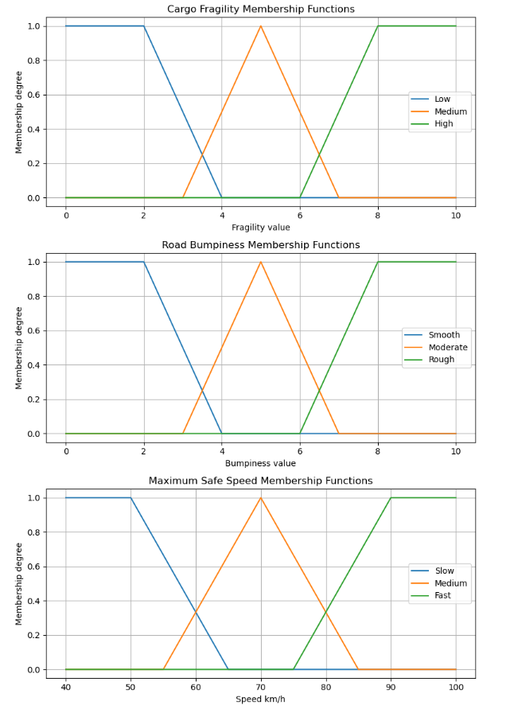Figure 2 shows the membership functions used in the fuzzy inference system. The first plot represents cargo fragility, the second plot represents road bumpiness, and the third plot represents the maximum safe speed output. The input variables use a 0 to 10 scale, while the output speed uses the required 40 to 100 km/h range.
The overlap between neighbouring sets is important because delivery conditions are not always clearly separated. For example, a cargo fragility value near 6.5 can partly belong to both Medium and High. In the same way, a road segment can be partly Moderate and partly Rough. This overlap allows multiple fuzzy rules to activate at the same time, which gives a smoother and more realistic safe-speed result.

2.3 Rule Matrix and Rule Base
The fuzzy rule base is designed around one practical idea: when fragility or bumpiness increases, the safe speed should decrease. The rule matrix is shown below.
Table 4. Fuzzy Rule Matrix
Fragility \ Bumpiness | Smooth | Moderate | Rough
Low | Fast | Fast | Medium
Medium | Fast | Medium | Slow
High | Medium | Slow | Slow
The full rule base is:
IF Fragility is Low AND Bumpiness is Smooth THEN Speed is Fast.
IF Fragility is Low AND Bumpiness is Moderate THEN Speed is Fast.
IF Fragility is Low AND Bumpiness is Rough THEN Speed is Medium.
IF Fragility is Medium AND Bumpiness is Smooth THEN Speed is Fast.
IF Fragility is Medium AND Bumpiness is Moderate THEN Speed is Medium.
IF Fragility is Medium AND Bumpiness is Rough THEN Speed is Slow.
IF Fragility is High AND Bumpiness is Smooth THEN Speed is Medium.
IF Fragility is High AND Bumpiness is Moderate THEN Speed is Slow.
IF Fragility is High AND Bumpiness is Rough THEN Speed is Slow.
These rules are simple on purpose. I wanted the system to be easy to explain because the route planner should not behave like a black box. If the agent slows down or avoids a route, the reason should be visible from the rule base.
For example, a smooth road with low-fragility cargo allows a fast speed. However, a rough segment with high-fragility cargo produces a slow speed. This matches the delivery context because rougher movement can increase the chance of damage, especially when the cargo is fragile.

2.4 Fuzzification, Rule Activation, Aggregation, and Defuzzification
The fuzzy system follows a Mamdani-style inference process.
First, the crisp input values for fragility and bumpiness are fuzzified. This means each value is converted into membership degrees across the relevant fuzzy sets.
Second, the rules are activated. For each rule, the AND condition is calculated using the minimum operator. For example, if a segment is partly Medium fragility and partly Rough bumpiness, the rule strength is the smaller membership degree of those two inputs.
Third, the output membership functions are clipped according to the rule strengths. The outputs from all active rules are then combined using max aggregation. This keeps the strongest contribution from the active rules.
Finally, centroid defuzzification is used to produce one crisp safe-speed value. I used centroid defuzzification because it gives a balanced output and avoids a sudden jump between categories. This is useful in a delivery situation because the system should adjust speed gradually when road or cargo conditions change.

2.5 Representative Fuzzy Example
To check that the fuzzy system behaves sensibly, I tested one representative road segment with:
Cargo Fragility = 7
Road Bumpiness = 6
This is a useful example because both values sit near overlap regions. The cargo is leaning toward high fragility, and the road condition is between moderate and rough. This means more than one rule can be activated at the same time.
The final crisp output from the fuzzy system was:
Maximum safe speed ≈ 50.71 km/h
Figure 3. Defuzzification Output for Representative Segment
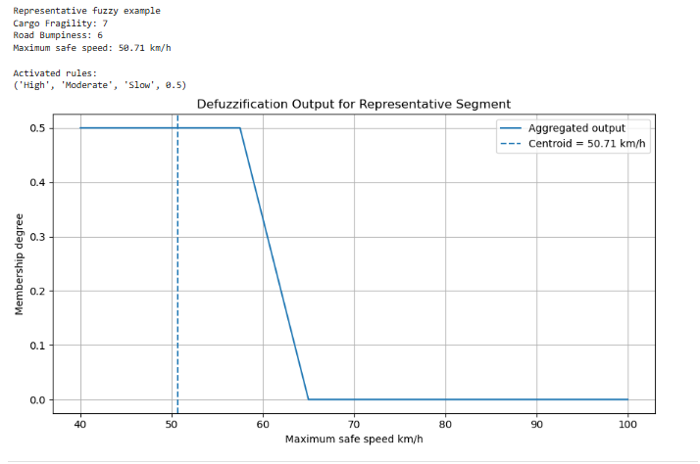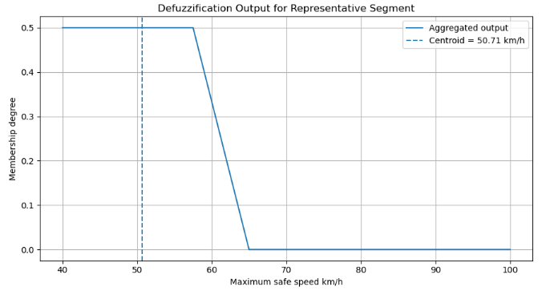
Figure 3 shows the aggregated fuzzy output for the representative case where cargo fragility is 7 and road bumpiness is 6. The dashed line shows the centroid defuzzification result, which gives a maximum safe speed of approximately 50.71 km/h. This result is reasonable because the cargo is fairly fragile and the road condition is moving toward the rough category, so the system recommends a slower safe speed.

3. Integrated Intelligent System, Replanning, and Responsible Evaluation
3.1 Hybrid System Design
The integrated system combines the A* route planner from Task 1 with the fuzzy inference system from Task 2. The fuzzy system calculates a safe speed for each road segment, and A* uses that speed to calculate travel time.
In the baseline system, every segment uses the same speed:
travel time = distance / 100
In the integrated system, each segment uses its fuzzy safe speed:
travel time = distance / fuzzy_safe_speed
This changes the meaning of the edge cost. In the baseline, a segment is only affected by distance. In the integrated model, a segment is affected by distance, bumpiness, and cargo fragility. This is a better fit for the delivery problem because the fastest route should still be safe for the goods.
The integrated system was tested using three fragility levels:
Case | Fragility Value
Low fragility | 2
Medium fragility | 5
High fragility | 8
This allows the system behaviour to be compared under different cargo conditions.

3.2 Fuzzy-Informed Heuristic and Admissibility
For the integrated A* planner, I kept the heuristic conservative. The heuristic still uses straight-line distance divided by the maximum possible speed of 100 km/h:
h(n) = straight-line distance to goal / 100 km/h
I made this choice because the heuristic must not overestimate the real remaining travel time. In the fuzzy system, the maximum safe speed can be as high as 100 km/h, but many segments will be slower than this when the road is rough or the cargo is fragile. Therefore, using 100 km/h in the heuristic gives an optimistic estimate.
A key reason this heuristic remains admissible is that it uses the maximum possible speed in the system, which is 100 km/h. In the integrated fuzzy model, the actual safe speed for a segment can only be equal to or lower than this value, depending on cargo fragility and road bumpiness. Therefore, the heuristic gives a best-case estimate of the remaining travel time. In other words, h(n) does not overestimate the true remaining cost h*(n). This supports A* in finding an optimal path under the defined cost model while still allowing fuzzy logic to influence the actual edge costs.
This is important because a more aggressive fuzzy heuristic could accidentally overestimate the remaining cost. For example, if the heuristic assumed that all future segments would be slow, it might estimate a higher remaining cost than the actual best path. That would weaken the admissibility of A*. For this reason, I used fuzzy logic in the actual edge cost, but kept the heuristic based on the maximum possible speed.
This means the integrated planner is still guided toward the goal, but the final route decision is mainly shaped by the fuzzy travel-time cost.

3.3 Integrated Results Across Fragility Levels
After integrating fuzzy safe speeds into the A* planner, I compared the results against the baseline route.
Table 5. Baseline vs Integrated A* Comparison
Case | Fragility Value | Path | Total Distance km | Total Time minutes | Difference from Baseline
Baseline | - | N1 → N3 → N5 → N10 → N9 | 0.990 | 0.594 | 0.000
Low fragility | 2 | N1 → N3 → N5 → N10 → N9 | 0.990 | 0.655 | +0.061
Medium fragility | 5 | N1 → N3 → N5 → N10 → N9 | 0.990 | 0.673 | +0.079
High fragility | 8 | N1 → N3 → N5 → N10 → N9 | 0.990 | 0.882 | +0.288
The results show a clear pattern. As the fragility value increases from 2 to 5 to 8, the total travel time also increases from 0.655 minutes to 0.673 minutes and then to 0.882 minutes. This happens because the fuzzy system lowers the safe speed when the cargo becomes more fragile, especially on moderate or rough road segments.
In these three tests, the route did not change, but the travel time did. I still think this is an important result because the planner was no longer treating every road segment as equal. The same route became more costly when the cargo was more fragile. This shows that the integrated system is not simply choosing the shortest-looking path. It is evaluating the path based on both travel time and cargo safety.
This also shows why the integrated system is more realistic than the baseline. The baseline assumes that the same road segment always has the same travel time. The fuzzy-informed system recognises that the same road can become slower when the cargo is more fragile or the road condition is less suitable.
Table 6. Edge Safe Speed Examples
Edge | Distance km | Bumpiness | Bumpiness Value | Low Fragility Speed | Medium Fragility Speed | High Fragility Speed
N1–N3 | 0.154 | Smooth | 2.0 | 90.74 | 90.74 | 70.00
N2–N5 | 0.309 | Moderate | 5.0 | 90.74 | 70.00 | 49.26
N3–N4 | 0.230 | Rough | 8.0 | 70.00 | 49.26 | 49.26
N6–N12 | 0.478 | Rough | 8.0 | 70.00 | 49.26 | 49.26
N8–N9 | 0.221 | Smooth | 2.0 | 90.74 | 90.74 | 70.00
Table 6 helps explain what the fuzzy system is doing. A smooth edge can still allow a high speed for low or medium fragility cargo, while a rough edge reduces the speed more strongly. This table is useful for explainability because it connects fuzzy reasoning directly to the A* route cost.
For example, the rough edge N3–N4 allows a speed of 70.00 km/h when fragility is low, but only 49.26 km/h when fragility is medium or high. This can be explained directly from the fuzzy rule base: rougher road conditions and higher fragility activate rules that lead toward the Slow speed output. Because of this, the planner’s decision is not hidden. The reason for a higher travel-time cost can be traced back to the fuzzy membership values, rule activation, and final safe-speed output.
Figure 5. Integrated A* Route with High Fragility
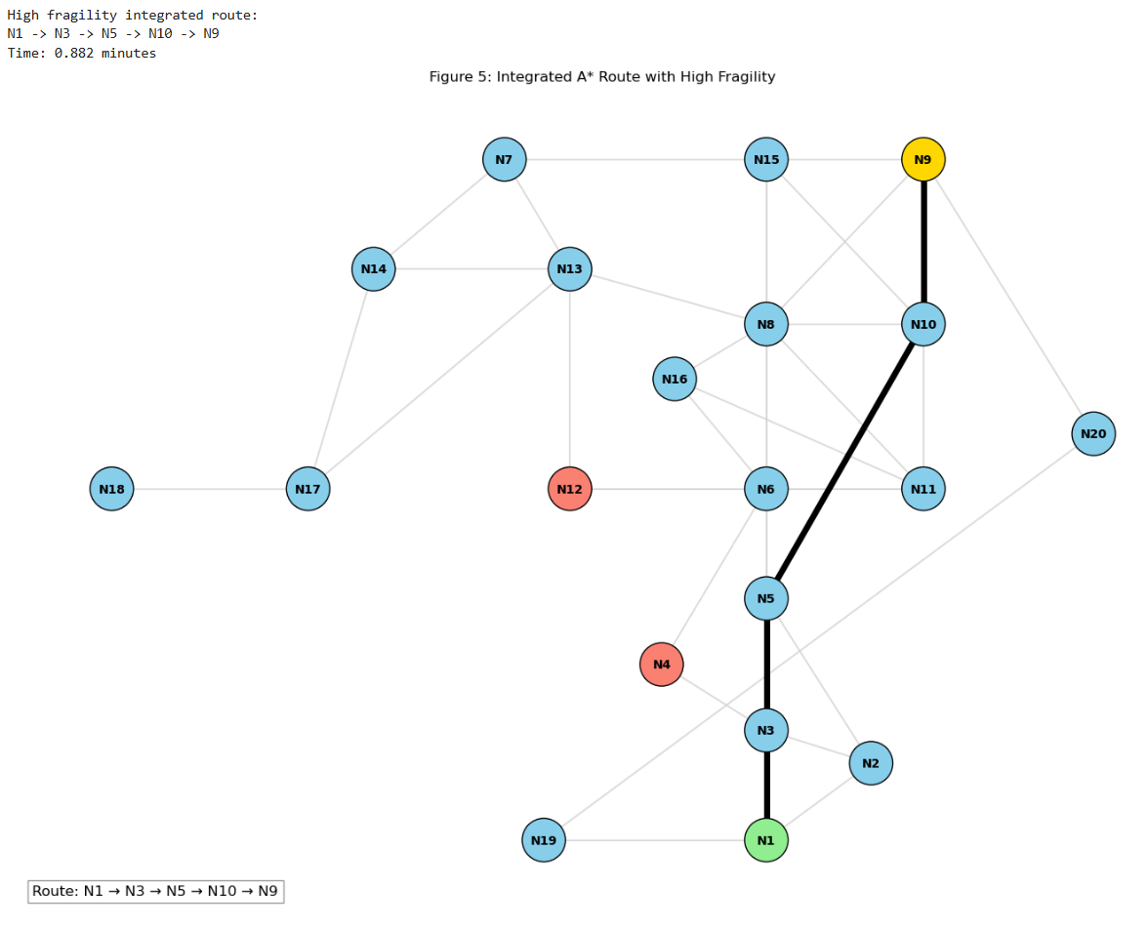
Figure 5 shows the route selected by the fuzzy-informed A* planner when the cargo fragility value is high. In this experiment, the selected path remains N1 → N3 → N5 → N10 → N9, but the travel time increases because higher fragility lowers the safe speed on some road segments. This figure provides a visual comparison with the baseline route.

3.4 Replanning Under School-Zone Constraint
The next part of the system tests how the agent responds when the environment changes during the journey. After 20% of the originally planned route has been travelled, a school-zone condition begins. From that point, 60% of the graph edges are constrained by a 40 km/h speed cap.
I used a fixed random seed to select the constrained edges:
random seed = 215
This makes the experiment reproducible. The same 60% of edges are used for all fragility cases, so the comparison is fair.
For school-zone constrained edges, the effective speed is calculated as:
effective speed = min(fuzzy_safe_speed, 40)
For unconstrained edges, the speed remains:
effective speed = fuzzy_safe_speed
The agent replans from its current node rather than from the original start node. This is an important part of the system because it reflects a realistic delivery situation. If a road condition changes mid-journey, the truck should not restart the whole plan from the beginning. It should update the remaining route from where it currently is.
Because the original planned route contains five nodes, 20% of the route corresponds to one visited node after rounding up.
In this implementation, the replanning trigger is applied immediately after the initial route is generated, before the agent actually moves to the next node. Because of this, the school-zone condition is activated while the agent is still at N1.
This is simply how the simulation was structured, so the agent replans from the starting node rather than after reaching N3. Although this occurs near the beginning of the route, the replanning logic is still applied from the current node as required.
Table 7. School-Zone Replanning Results
Case | Original Planned Path | Current Node after 20% | Actual Travelled Path after Replanning | Original Distance km | Actual Distance km | Original Fuzzy Time | Actual Replanned Time | Time Change
Low fragility | N1 → N3 → N5 → N10 → N9 | N1 | N1 → N3 → N5 → N6 → N16 → N8 → N9 | 0.990 | 1.279 | 0.655 | 0.974 | +0.320
Medium fragility | N1 → N3 → N5 → N10 → N9 | N1 | N1 → N3 → N5 → N6 → N16 → N8 → N9 | 0.990 | 1.279 | 0.673 | 1.069 | +0.396
High fragility | N1 → N3 → N5 → N10 → N9 | N1 | N1 → N3 → N5 → N10 → N9 | 0.990 | 0.990 | 0.882 | 1.360 | +0.477
The replanning results show that the reactive layer is working as intended. For the low and medium fragility cases, the actual travelled path changed from the original route to a longer alternative route through N6, N16, and N8. This happened because the school-zone speed cap changed the effective travel-time cost of selected edges, so the original path was no longer the best option under the updated environment.
For the high fragility case, the route stayed the same, but the travel time still increased from 0.882 minutes to 1.360 minutes. This is also meaningful because replanning does not always have to produce a different path. Sometimes the rational decision is to keep the same path if the alternatives are not better, while still updating the cost to reflect the changed speed conditions.
Overall, this comparison shows that the agent is adaptive rather than static. It does not blindly follow the original plan. Instead, it updates its decision after the school-zone condition appears and replans from the current node, which matches the behaviour expected from a reactive intelligent system.

3.5 Reactive Agent-Environment Flowchart
Figure 6. Reactive Agent-Environment Flowchart
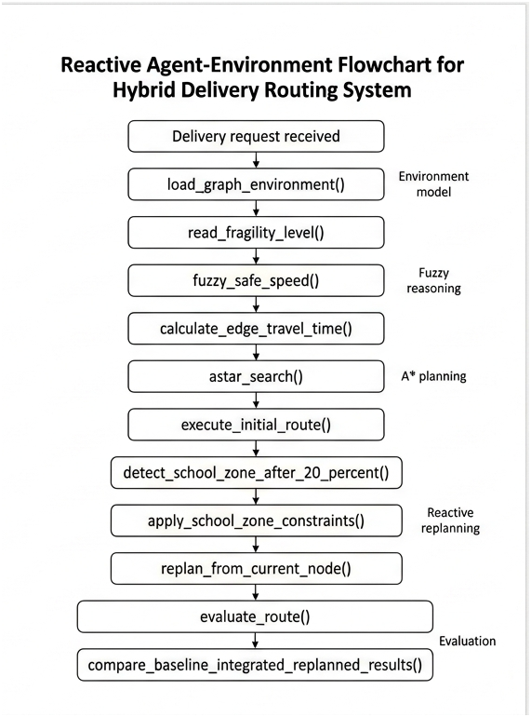
Figure 6 shows how the agent combines fuzzy reasoning, A* search, and replanning. The function names in the diagram match the implementation in the notebook, including fuzzy_safe_speed(), astar_search(), apply_school_zone_constraints(), and replan_from_current_node(). This shows how the conceptual agent-environment loop is connected to the actual code.
The reactive layer is important because it connects the three major parts of the system. The fuzzy system provides safe speeds, A* uses those speeds to plan a route, and the replanning layer updates the path when school-zone constraints change the environment.
This flow also shows why the system can be described as a hybrid intelligent system. It does not rely on only one method. Search is used for route planning, fuzzy logic is used for uncertain speed reasoning, and replanning is used to handle environmental change.

3.6 Responsible and Rational Behaviour
The system is designed to make rational delivery decisions, not just fast ones. In this problem, speed matters, but it should not be the only goal. A delivery agent also needs to protect the cargo, respect road conditions, and respond safely when the environment changes.
One responsible design choice in this project is safety over speed. The fuzzy system reduces the maximum safe speed when the cargo is fragile or when the road segment is rough. This means the agent may accept a slightly longer travel time if that reduces the risk of damaging goods. This is important because a route that looks fast under a constant-speed assumption may not be safe for fragile cargo.
The school-zone replanning layer also supports public safety. When the school-zone condition begins, selected road segments are capped at 40 km/h. The agent then replans using the updated costs instead of continuing blindly with the original plan. This shows that the system can respond when safety constraints become more important than the original travel-time estimate.
The system is also explainable. If someone asks why the agent changed route or why a segment became less attractive, the answer can be traced through a clear chain: input values, fuzzy membership degrees, rule activation, safe-speed output, edge travel-time cost, and A* route selection. For example, a rough road with high fragility produces a lower fuzzy safe speed. That lower speed increases the travel-time cost for that segment, so A* may choose another path. This makes the decision easier to review and justify.
There are also ethical and safety considerations. In a busy city environment, a delivery system should not optimise speed in a way that increases risk for pedestrians, school-zone users, or fragile cargo. The fuzzy safe-speed model helps the agent slow down when the conditions are less suitable, while the replanning layer shows that the agent can adapt when new constraints appear.
From a cybersecurity perspective, the system depends on correct environmental data. If bumpiness values, speed restrictions, or school-zone information were changed incorrectly, the planner could make unsafe or inefficient decisions. A real version of this system should validate map updates, protect routing data, and log replanning decisions so that unusual changes can be checked later.
Overall, the system behaves more responsibly than the baseline because it does not only chase the quickest route. It also considers whether the speed is safe for the cargo and whether the route is affected by changed road conditions.

4. Conclusion
This project combined A* search, fuzzy safe-speed reasoning, and reactive replanning into one delivery routing system. The fuzzy-informed planner was more realistic than the baseline because it adjusted travel time based on cargo fragility and road bumpiness. The replanning layer also made the system more adaptive when school-zone constraints changed the environment.

Acknowledgement
I used my previous SIT215 Assignment 1 graph model and Assignment 2 fuzzy logic design as the starting point for this project. I then adapted them to meet the Assignment 3 requirements, including distance-based A* search, fuzzy safe-speed calculation, and replanning under school-zone constraints.

References
Hart, P. E., Nilsson, N. J., & Raphael, B. (1968). A Formal Basis for the Heuristic Determination of Minimum Cost Paths. IEEE Transactions on Systems Science and Cybernetics.
NetworkX Developers. (2026). Shortest Paths. NetworkX Documentation.
Russell, S., & Norvig, P. (2022). Artificial Intelligence: A Modern Approach.
Google. (2026). Google My Maps.
Jin Kim. (2026). SIT215 Assignment 1: Problem Solving Task.
Jin Kim. (2026). SIT215 Assignment 2: Intelligent System Design with Fuzzy Logic.
SIT215 Computational Intelligence. (2026). Assignment 3: Integrated Intelligent System Project Task Sheet

